sssCourse: COMP1640

Enterprise Web Software Development

Submitted to: Dr. Ray Stoneham Name

Course leader

University of Greenwich, UK

Submitted by:

Md. Amzad Hossen

Banner ID: 000989717

Submission date: 13th December 2017

Group name: "Group-T'

Grou members:

|  |  |  |
| --- | --- | --- |
| SL. | Name | Role(s) |
| 1 | Md. Amzad Hossen | Tester |
| 2 | Sazzadul Alam | Programmer |
| 3 | Tahera Mohammad Salim Sarker | System Analyst and Database Desi ner |
| 4 | Abdullah Alam Ibnu Raihan Mahmood Ratul | Web Designer |



Credentials:

SL. Username Password Role

|  |  |  |
| --- | --- | --- |
| 1  2    3  4  5  6 |  | Student  Student  EC manager  EC Coordinator  EC Coordinator Admin |
|
|  |  |

Table of Contents

Table of 

1. Evaluation of product and process: . — .6

System requirements met: .

Agile Process:

Strength of the system:..............................8 Weakness of the system:

Further improvement: ............................................................ .. 9

1. Evaluation of team: .... 9
2. Self Evaluation:11
3. Appendices:.14

1. APPENDIX A: Test Plan and Test Log.. 14

Testing for web apps:....14



Objectives: .14

Test scope and Testing strategies:..16 Test Logs and Execute:

References: ..........................................................„..................................................................................... 66

Table of Figures:

Figure I Web applications testing cycle . .16

Figure 2 Username and password entered... ..21

Figure 3 Login successfully to the student page with dashboard

Figure 4 Claim submission option selected from the menu .22

Figure 5 submitting a new claim ............................................,...................... . 23

Figure 6 Claim submitted successfully . 23

Figure 7 Uploading evidence option selected............ . .24

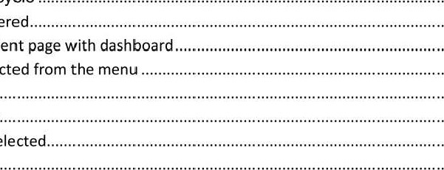

......22

Figure 8 View the submitted claim ......................„......................................... 24

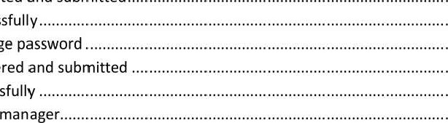Figure 9 An evidence file were selected and submitted. .24 Figure 10 Evidence uploaded successfully............. ...25 Figure Il shows the option to change password .26 Figure 12 A new password was entered and submitted . .26 Figure 13 Password changed successfully ..27 Figure 14 username "sarwer" as EC.28 Figure 15 EC manager can see the summary in dashboard and can view claims.......................................28

Figure 16 Select sub menu for display

Figure 17 EC manager can oversee all claims

Figure 18 Can oversee details of any particular claim information Figure 19 username "siplu" as EC Coordinator login .... .

Figure 20 this figure show EC Coordinator homepage and dashboard .

Figure 21 EC Coordinator can view all the claims by filtering.....................................................................31

Figure 22 EC Coordinator processes claim...

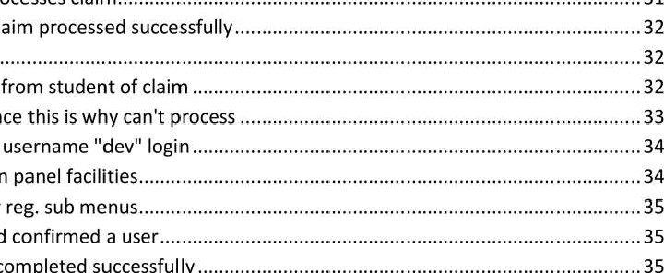

..31

.35

Figure 23 Message shows Claim processed successfully ..

Figure 24 Proof of Approval

Figure 25 Email notification from student of claim .

Figure 26 There is no evidence this is why can't process

Figure 27 Here is the admin username "dev" login

Figure 28 Figure show admin panel

Figure 29 Admin menu User reg. sub

Figure 30 User reg. page and confirmed a

Figure 31 User registration completed successfully —

Figure 32 admin can inactive and active a role from the system ...............................................................36 Figure 33 User reg. updated successfully .

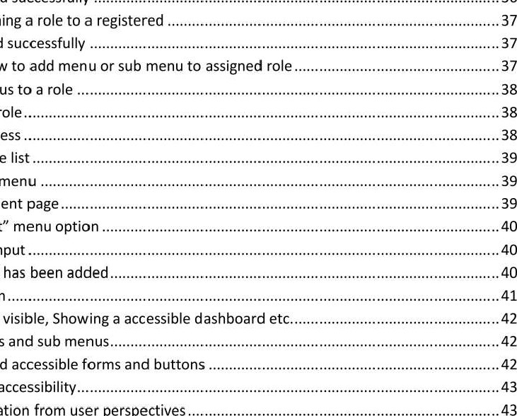

.36

43

Figure 34 Option for assigning a role to a registered

Figure 35 User role defined successfully

Figure 36 Figure shows how to add menu or sub menu to assigned role

Figure 37 How to add menus to a role

Figure 38 Option to add a

Figure 39 Role adding process — Figure 40 Role added to the list

Figure 41 Assessment sub menu .

Figure 42 Manage assessment page .. ....

Figure 43 "Add assessment" menu option . Figure 44 An assessment input

Figure 45 New assessment has been added..

Figure 46 Usable login form

Figure 47 Navigation is are visible, Showing a accessible dashboard Figure 48 accessible Menus and sub

Figure 49 Clearly visible and accessible forms and buttons .

Figure 50 Another type of accessibility...

Figure 51 Accessible navigation from user perspectives

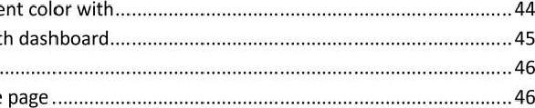Figure 52 Login shows a good color matching with the overall interface ..................................................44 Figure 53 this section show different content color

Figure 54 Chrome result of Home page with dashboard..

Figure 55 Mozilla Firefox show this result ,

Figure 56 Internet Explorer result of Home page .....................„

Figure 57 compatible with iPhones......................„.............................. .48

Figure 58 Compatibility test with iPad.49 Figure 59 Compatibility testing with Lumia 920 .50

Figure 60 Compatible with a minimum smal screen of Galaxy Y........... . . ...51 Figure 61 Providing printing command with foxit reader printer ......52

Figure 62 Compatibility testing with print and print preview home page ..... ............................53

Figure 63 Figure shows database is connected with system .55

Figure 64 Queries executed successfully .. .56 Figure 65 the above figures show performance testing .58 Figure 66 Show report the stress of webApp . .59 Figure 67 System doesn't allow force .60 Figure 68 passwords are encrypted, .60

Figure 69 an attempt to attack hacking password . .62

Figure 70 Prevents illegal .63

Figure 71 Unauthorized username and password entered 64 Figure 72 Shows "Incorrect username' . ....65

1. Evaluation of product and process:

Our task was to develop enterprise web software adopting with agile scrum. Since it's a group work so, we played different role in this course work alongside agile scrum methodology. Now I am here to evaluate the product and its process.

System requirements met:

We have been asked build role based web software for a large university student so that they submit claim of Extenuating Circumstances (EC). The system should meet some requirements or criteria; we need to reflect on those criteria during the development of the product:

* + EC manager will be able to view the entire claim stored in the system, but he won't be able to process any submitted claim. It should be compatible for all kinds of devices and secure as well as.
  + Students can submit EC claims based on different assessment in one

designated facility. After that they will be notified shortly via email that their submitted EC. Can view claims as well as.

* + EC Coordinator allows claim to be approved according to each faculty, can oversee the all claim and can process. After submitting a EC claim, EC coordinator will be notified via mail. EC Coordinator can't process any claim without any submission, validity of claim will expiry maximum 15 days.
  + An admin can do anything within the system, to be honest, admin have the power of manage the whole EC claim software like role base management, setting up the closure date and final date of EC and can add different assessment to list.
  + Statistical analysis of the stored data like graphical presentation of data it can be a chat or something else. It will produce number of reports depending on different type of needs.

(To see all the functionaries and features please go to the my Appendix part OR visit the group-reposjtg.y)

Agile Process:

We have worked together by practicing and adopting the agile scrum methodology. We have recorded the meeting minutes when we did meeting together for our own good. Our group was combining four (4) person based on roles such as information architect, web designer, database designer and tester basically.

We always tried to adopt the agile scrum philosophy during the development of the entire system; the most important things observed from the very beginning from our assignment, these are:

* + Product backlog: A list of requirement based on the priority was build for making the product more valuable
  + Sprint: A little piece of work from product backlog was developed.
  + Scrum meeting: We conducted many meetings up to 1 hour duration, different type of problems are discussed there.

Strength of the system:

* + The system has secured role based functionalities so everything is under the control of admin that ensures whole security of the system.
  + One of the most important think is responsiveness of the system it can be compatible with all other device and beyond the platform people use.  It can produce different reports based on different assessment and it has dashboard that displays the entire claim from role's perspective.
  + Manageability is the great feature of this system, so that admin can manage whole system and take any changes needed.
  + System can take a huge load of pressure when student are intended to claim submission from different place and from large number of student.
  + It has great usability and UI design help people to use the system easily. And lots feature to be used

Weakness of the system:

* + There are some minor defect related to data with some browsers
  + Need to be hosted in a good qualified server
  + There is a compromise with UI design, some parts are designed badly comparatively

Further improvement:

* + A Live chat feature would be a good part to be developed in future

Application performance can be increased in future

* + Security should be more strict in further development
  + Making more responsive the system
  + Making system's UI more useful.

1. Evaluation of team:

Weighting factor for each student (Scale 0 to 10)

|  |  |
| --- | --- |
| Commitment | Wei ht |
| Full committed | 10 |
| Committed | 8 |
| Contributed substantiall | 6 |
| Contributed artiall | 4 |
| Minimal contribution | 2 |
| No contribution |  |

A scoring model of entire team including myself (Scale O to 10):

|  |  |  |
| --- | --- | --- |
| Group members | Wei ht score |  |
| Md. Amzad Hossen |  | 8 |
| Sazzadul Alam |  | 8 |
| Tahera Mohammad Salim Sarker |  | 6 |
| Abdullah Alam Ibnu Raihan Mahmood Ratul |  | 8 |

Collaboration:

Collaboration of the group members is one of the main virtues that made us more helpful to carry out the project along with the agile scrum practices; we have worked collaboratively with other in needs.

Participation:

Without some moment everything was fair and lovely. Everyone has contributed their own efforts best they could in from their own perspectives. They have given their

individual effort based on their

Attitude:

Other group member's attitude was awesome from everyone's perspective, they always showed a positive attitude to me and took every single feedback positively that I gave.

Independence:

We worked independently without any barrier of other team members. They always encourage each other to go ahead with the assignment. So that we can do our specific work timely.

Communication:

Communication was our main key aspects to move forward with the development of the software. Everyone has expressed their thinking each other like what they, what want to do, what can be done, how to do any why etc. So that we can keep in touch to development the system within the limited.

Responsiveness

For any reason our group member was very responsive, they reacted positively when asked something about the project. There was no such verbal and non verbal consistency in other team members.

3. Self Evaluation:

This is my honest description of my own contribution to our group to be developed the software. This part reflects based on my performance that performed during the whole process of the coursework:

Effective use of time.

It's a great opportunities to me to learn something like this. Now, I can do something like this timely and with a limited time.

Leadership:

As a tester I very often led the group to do group activities on time, to make the system more dynamic and business values. If there is problem with something I tried to solve with other team members to get rid of something like this.

Contribution to team effort:

I have played a role of system tester, as a tester I have tested major parts of the web software so that as a member of team I can help other team members. My approach was always contribute to team so that I can do better that any other member as my perspective.

Completion of assigned or agreed-upon responsibilities:

I always tried to do my responsibilities that are assigned to me and I have completed majority percent of the own responsibilities time to time. I have tried to complete successfully my responsibilities on my defined duties.

Completion of assigned or agree-upon tasks on time:

This is one of plus point for me to complete every task on time and make the team more dynamic to be developed the system. Sometime, I have not done some tasks for inconvenience due to force of nature.

Participation in team meetings:

I was always present and punctual in team meetings. Any problems that are facing out team, sometimes, I have suggested the way of solution to all the group members.

Quality of written contribution to team effort:

I have written the report and my assigned writing part very precisely as I can do my best. Every section in individual part and group part I written, quality was good enough.

Appropriate writing is written in appropriate place where it carries a value.

Lesson learnt:

After completing the group coursework, I have leant how to adjust, communicate, react and collaborate with different types of people in information technology sector, especially in web development sector alongside the agile scrum process and methodology.

4. Appendices:

1. APPENDIX A: Test Plan and Test Log

Test plan is the documentation of planning of what activities need to be tested including scope and approach within specific resource and schedules. It defines different area of intended testing of the web application, such as: items that need to be tested, functions or features, tasks will be tested, the person who will perform test tasks, setup environment of the testing, techniques related to test design and so on.

(softwaretestingfundamentals.com, n.d.)

Testing for web apps:

In the web applications, testing is a key and important part of the project. Technically, testing is carried out late time comparatively in the whole project processes and conducted within a small time. So, it is suggested to conduct the testing part so that tasks ensure high quality of the product. It ensures the correctness of the systems that intended to be, like other conventional software testing. (Pressman, 2010)

Objectives:

There are some objectives of testing thee web application, the goals and purposes of the behind the testing. Although, it not possible to make sure that the web application has to be perfect but it's a testing of whether the application met the requirements or not including:

* To check whether the intended functionalities of product met or not, it could be functional and non functional.
* To check the correctness of the functional errors that about to be encountered.  If users can use the web app easily in terms of usability; how usable the app is.  Checking the application interfaces that are been designed and developed

 Any problems or issues of database that are related to operations of program.

* Whether the application compatible or not with deferent platform.
* Overall performance of the system using different way.
* To ensure security of the system as client indented and so on. (Kota, 2016)

Test scope and Testing strategies:

There are many testing criteria and some strategies to carry out the testing process of this web product. Technically, these are the core portion or parts of a web application that need to be tested, these are:

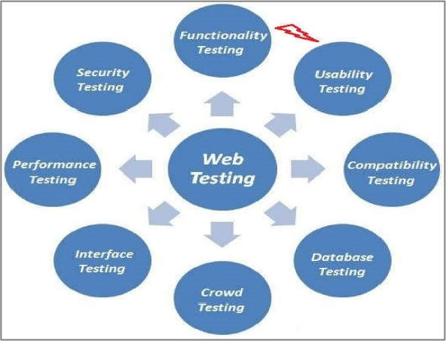

(SoftwareTestingClass.com, 2012)

Figure 1 Web applications testing cycle

A brief description of what testing need to be carried out:

1. Functional testing

Testing of the functional component of the web application we developed. That included functional and some non functional testing. Technically, it is conducted to make sure that the application satisfied the client expectation. This includes some other testing procedures like different links, web forms, cookies test etc.

(SoftwareTestingClass.com, 2012)

* User login
* Going to the proper page based on the user role
* If error occurs show message
* Checking of allowance to change their password
* View all the claims
* EC manager's page opens
* Shows all the claim made
* Doesn't let any claim to be processed
* Manage claims
* Claim will be approved according to faculty
* Shows all the claims and allows them to be processed
* Receive mail and notification of claim and the time remaining to process
* Doesn't let claims to be processes without any evidence
* Cannot be able to enter after any claim after 15 days

# • Claim submission

* Can submit claims for different assessment for one's designated faculty
* Can upload evidence of claim
* Receive mail about claim progress
* Can view all of their claim details
* System management
* Can manage whole role base management of the user
* Set closure and final date for EC claim
* Can add new assessment to the assessment list.

1. Testing of Usability:

This is one of the most important parts of a web app; a tester will carry out the testing of usability of the app. It requires the

* + - Navigation
    - Content testing of the web application, what are easy enough to use

1. Compatibility testing:

Checking the compatibility of the webapp, after all it's a non functional testing. It ensures how compatible the web application is to the users, in terms of working environments, OS, browser, hardware configurations, internet speed etc. It involves:

* + - * Browser compatibility,  Different OS,
      * Mobile platform and
      * Printing of web page. (SoftwareTestingClass.com, 2012)

1. Testing of interfaces:

Different sections of interfaces of the application are covered such as: web, application and database server are tested from different point of views. It ensures the consistency of these three server communications and their behaviors. (SoftwareTestingCIass.com, 2012)

1. Database testing:

Purpose is to ensure reliability of data related the database, make sure that operational is secure and the way of dealing with the web application. How the application handles the database also is seen in terms of data manipulation.

* + - Error of query
    - Data integrity with CRUD function
    - Checking the time of to execute queries and
    - Any complex query

1. Performance testing:

It is about the performance of the web application, it deals with the performance during different circumstances like how much load it can take in a specific time.

These are carried out by:

* + - Web stress and
    - Web load testing of the web application.

1. Security testing•

It ensures the security of the web application, as we know as enterprise web software security is the main issue and challenge of this application. How the application handle the critical situation in terms of application's overall security.

Different testing criteria need to be tested.

* + - * Force of direct URL.
      * Try to upload malware
      * Sql injection
      * Login authentication
      * Brute force attack

1. Crowd testing:

This testing is conducted by tester in associated with a group of non technical person. This ensues how the group tell about the product and their feedback about your software. Also ensure the performance, usability of the system from their perspective if they feel good.

Test Logs and Execute:

Here are the test plans along with execution to see how they behave and show result against their expectations, with each test case. After that we can produce "Test

Plan" based on these activities:

|  |  |
| --- | --- |
| Test No. |  |
| Test type Functionality testing | |
| Test name User login | |
| Expected result Login to proper page based on role beside dash board | |
| How to test Input username and password of all roles | |
| Actual result Redirected to the role base page with a dashboard | |

* + User login page:

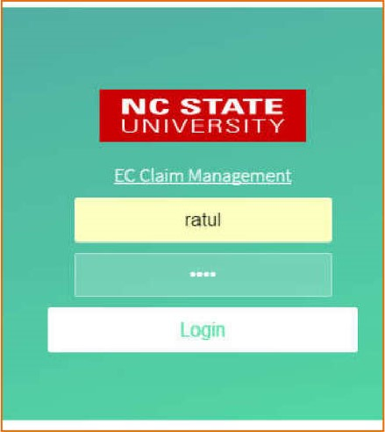

Figure

2

Username

and

password

entered

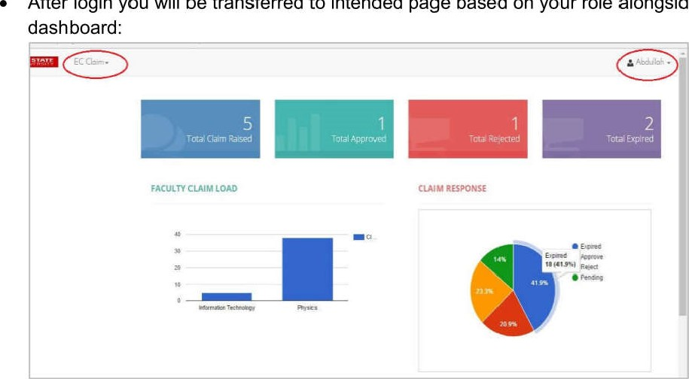

After

login

you

will

be

transferred

to

intended

page

based

your

role

alongside

Figure 3 Login successfully to the student page with dashboard

|  |
| --- |
| Test No. |
| Test type Functionality testing |
| Test name Submit claim and view own claim |
| Expected result Students will be able to submit claim |
| How to test By selecting assessment, reason, remarks and evidences |
| Actual result Claim submitted successfully, shown claim |

* + Here is the clam submission part from student perspective:

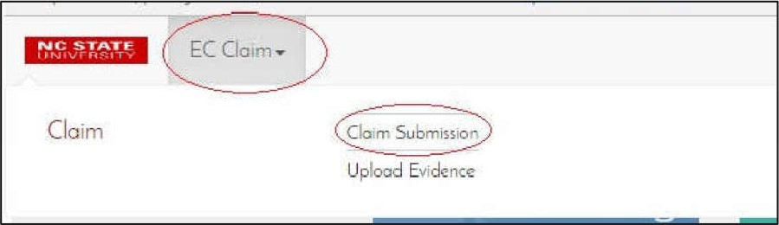

Figure 4 Claim submission option selected from the menu

* + Figure shows claim submission page and information are entered without evidences:

|  |
| --- |
| Student Claim Submission  Submit New Caim |

Figure 5 submitting a new claim

* + This part show that the situation after pressing the submit button:

|  |
| --- |
| Student Claim Submission  Success: Claim Submitted Successfully Claim NO - |

Figure 6 Claim submitted successfully

# 03

|  |
| --- |
| Test No.  Test type Functionality testing |
| Test name Re-upload evidences |
| Expected result Students will be able to upload evidences |
| How to test Open the submitted claim and re-upload evidences |
| Actual result Re-upload evidence successfully |

* Now I will upload the evidence (re-upload) from submitted claim:

|  |  |
| --- | --- |
| Claim. |  |
| Claim | Clan Submission |

Figure 7 Uploading evidence option selected

* This is the figure of how to view the claim that I submitted before:

|  |
| --- |
| p  Lat |

Figure 8 View the submitted claim

* This portion show that Re uploading evidence:

|  |  |  |  |
| --- | --- | --- | --- |
| Upload Evidence  Claim DetOfIs  Clam | | | |
| Date  Ret-rx'  'V | | | |
| |  |  |  |  | | --- | --- | --- | --- | |  | |  |  | | --- | --- | |  | Choose | | | | |  |
| algo 10 |
|  |  |  |

Figure 9 An evidence file were selected and submitted

* This section shows that the evidence upload confirmation:

|  |
| --- |
| Success: Evidence Successfully. Claim No : IT-00006 |
| Claim Details  IT-OOOOó 13 Apr,l, 2017   |  |  |  | | --- | --- | --- | |  | Rle |  |  |  | | --- | | View | |  |   No. 04 Evidence : I  View |

Figure 10 Evidence uploaded successfully

|  |
| --- |
| Test No.  04 |
| Test type Functionality testing |
| Test name Change password |
| Expected result System let change the password |
| How to test By putting another new passwords along with old password |
| Actual result Password changed successfully |

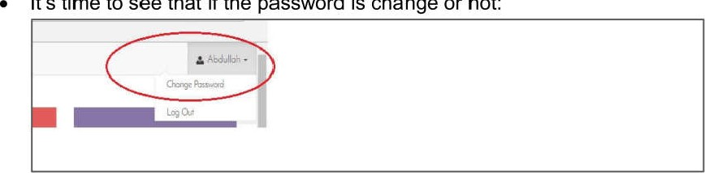

It's

time

to

see

that

if

the

password

is

change

or

not:

Figure 11 shows the option to change password

* Here is how the "change password" function works:

|  |
| --- |
|  |
| Change Password  Char,ge Password |

Figure 12 A new password was entered and submitted

* The confirmation that the password has been changed:

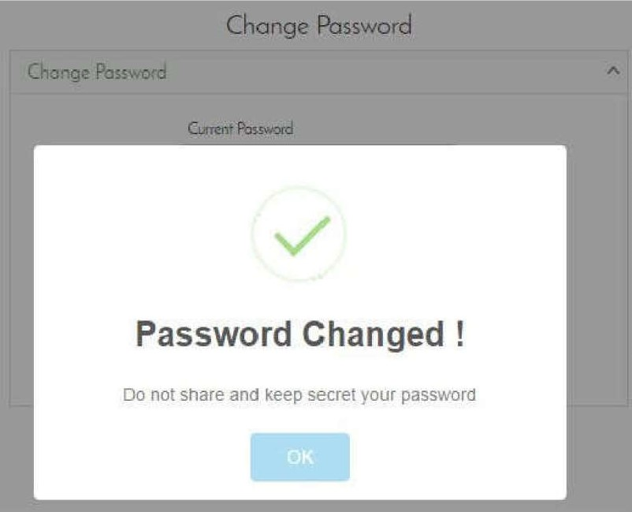

Figure 13 Password changed successfully

|  |
| --- |
|  |
| Test type Functionality testing |
| Test name View claims (EC manager) |
| Expected result EC manager page opens and can see all the claims made, but can't roceed |
| How to test Clicking view claim option |
| Actual result EC manager can view claim page and all the claims |

* This section display the view of claims as EC Manager submitted by students but he can't proceed the claims shown below step by step:

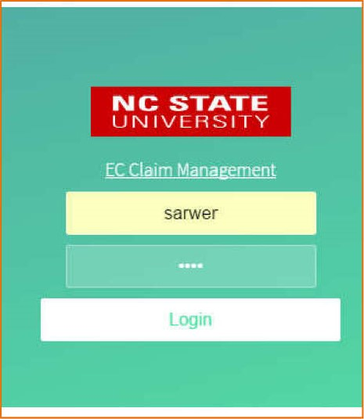

Figure

14

username

"sarwer"

as

EC

manager

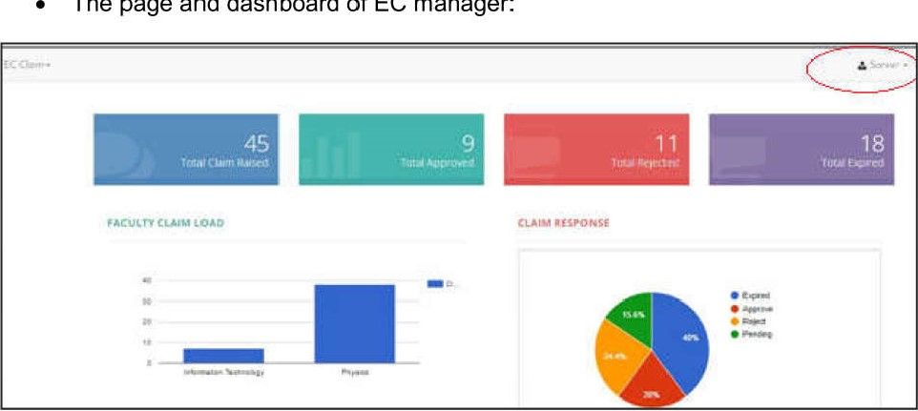

The

page

and

dashboard

of

EC

manager:

Figure 15 EC manager can see the summary in dashboard and can view claims

* Selecting nav bar in order to view claim:

|  |
| --- |
| EC |

Figure 16 Select sub menu for display claim

* Here are the claims that arisen can view from different option and by different filter or can download as excel file:

|  |  |  |  |  |
| --- | --- | --- | --- | --- |
|  | | | | |
|  |  |  | |  |
| Showing I rc 7 7 | | |  |

Figure 17 EC manager can oversee all claims

|  |  |
| --- | --- |
| Claim  O IT.oooos m 00006  Student Remarks: Due tc my illness here to  Claim Date 1] Apr,t. 2017  Of Evidence: r  Student Name: Rotul  Aging:  Claim Response  O PHV-COö'29 | EC claim  Serious arurv |

Figure 18 Can oversee details of any particular claim information

|  |
| --- |
| Test No. 06 |
| Test type Functionality testing |
| Test name Manage claim by EC coordinator |
| Expected result Clams will be shown to EC coordinator |
| How to test By clicking Claim Process sub menu |
| Actual result EC coordinator can see the claims |

* EC coordinator can oversee the claim to be processed:

|  |  |
| --- | --- |
| |  | | --- | | NC STATE  UNIVERSITY | |

Figure 19 username "siplu" as EC Coordinator login

|  |  |  |  |  |
| --- | --- | --- | --- | --- |
| |  |  |  |  | | --- | --- | --- | --- | |  | |  | | --- | | iota I | |  |   FACULTY CLAIM LOAD CLAIM RESPONSE |

Figure 20 this figure show EC Coordinator homepage and dashboard

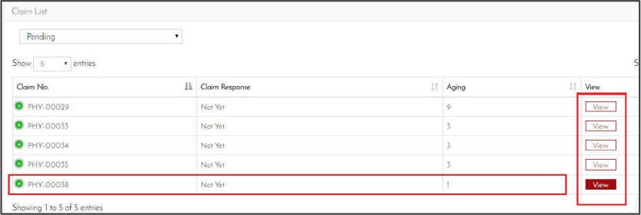

Figure

21

EC

Coordinator

can

view

all

the

claims

by

filtering.

|  |
| --- |
| Test No. 07 |
| Test type Functionality testing |
| Test name Manage claim by EC coordinator |
| Expected result EC coordinator will be able to process  claim |
| How to test Submitting approved/reject claim option |
| Actual result EC coordinator processed claim  successfull |

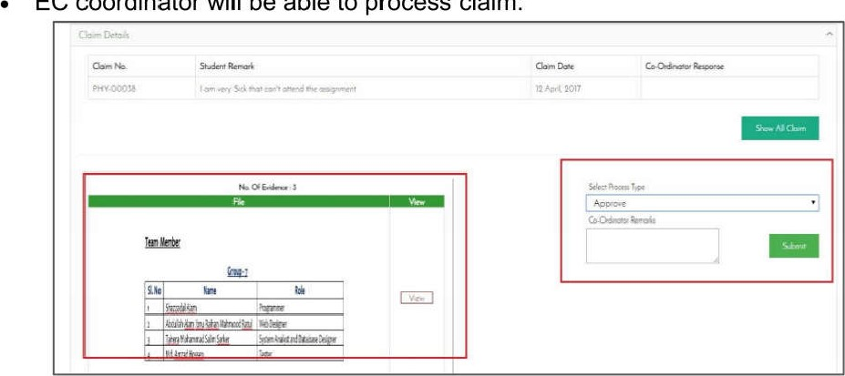

EC

coordinator

will

be

able

to

process

claim:

Figure 22 EC Coordinator processes claim

|  |
| --- |
| Success!  Claim Processed successrullyg |

Figure 23 Message shows Claim processed successfully

|  |  |
| --- | --- |
| O PHY-00038 |  |

Figure 24 Proof of Approval

## Test No. 08

|  |
| --- |
| Test type Functionality testing |
| Test name Receive mail notification |
| Expected result EC coordinator will receive an email notification |
| How to test By checking email after EC coordinator rocessed claim |
| Actual result EC coordinator have received email of claim rocessed |

* This part show mail from the EC Coordinators:

|  |
| --- |
| c |
| EC_Support EC Claim - EC Claim No - PHY-00038 Remarks I am very Sick that cant attend the assignment |
| Tech-Smith Account Servie Confirm your Camtasia Studio email - Welcome' To activate your TechSmith Account. please |

Figure 25 Email notification from student of claim

|  |
| --- |
| Test No. 09 |
| Test type Functionality testing |
| Test name Checking of process without evidence |
| Expected result EC coordinator can't process any clam if there is no evidence |
| How to test Try to process a claim without evidence |
| Actual result Doesn't let claim to be processed without evidence |

* System don't alow any claim to be processed withiout evidences:

|  |  |  |  |
| --- | --- | --- | --- |
| Ci,a'm  10  All   |  |  |  | | --- | --- | --- | |  | |  | | --- | | There is no option to | | |

Figure 26 There is no evidence this is why can't process

|  |  |
| --- | --- |
| Test No. |  |
| Test type Functionality testing | |
| Test name Claim expiry date | |
| Expected result EC coordinator unable to enter claim after 14 da s | |
| How to test Trying to process claim that expire 14 da s | |
| Actual result EC coordinator can't be able to process after 14 da s. | |

* After expiry date (14 days) claim will be legacy:

|  |
| --- |
| Test No. |
| Test type Functionality testing |
| Test name System management by admin |
| Expected result Admin will be able to manage |
| How to test By login to the Admin section |
| Actual result Admin able to manage the whole system |

* This is how the system admin (here, developer) can manage all funtiona and process of the system, in terms of claim facilities:

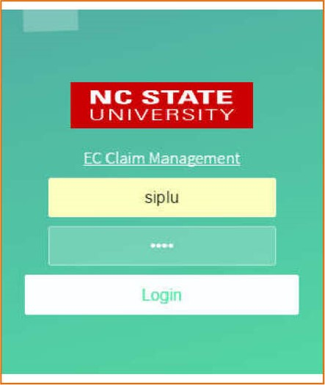

Figure

27

Here

is

the

admin

username

"dev"

login

* Here are the Admin facilities with different navigation and menus:

|  |
| --- |
| FACULTY CLAIM LOAD CLAIM RESPONSE |

Figure 28 Figure show admin panel facilities

* ADMIN can user registration:

|  |  |  |  |
| --- | --- | --- | --- |
| Admin   |  |  |  | | --- | --- | --- | | Admin |  | Acid Role  Aclcl Menu Menu |   Assessment Marage Assessment Assessment |

Figure 29 Admin menu User reg. sub menus

|  |
| --- |
| .com/RoleManager/UserRegistration |
|  |
| User Registration   |  |  |  |  |  | | --- | --- | --- | --- | --- | | |  |  |  | | --- | --- | --- | |  | Seaezt  Select   |  | | --- | | tahera |   Ihr Nome | |  | |

Figure 30 User reg. page and confirmed a user

|  |  |  |
| --- | --- | --- |
|  | | |
|  | Success! |  |
|  |

Figure 31 User registration completed successfully

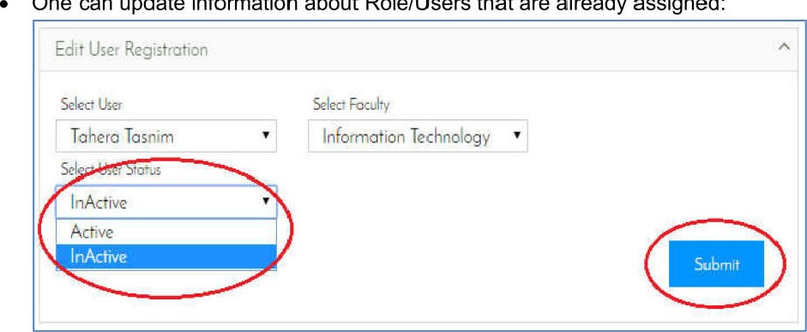

One

can

update

information

about

Role/Users

that

are

already

assigned:

Figure 32 admin can inactive and active a role from the system

|  |
| --- |
| Success!  user Registration Edited Successfully I |

Figure 33 User reg. updated successfully

* Admin can assign a role depend on the user reg.:

|  |  |  |  |  |  |  |  |  |  |  |  |  |
| --- | --- | --- | --- | --- | --- | --- | --- | --- | --- | --- | --- | --- |
| Role Assign   |  |  |  |  |  |  |  |  |  |  | | --- | --- | --- | --- | --- | --- | --- | --- | --- | --- | | |  |  | | --- | --- | |  | A lJtÆT | | Tahera | | |  | | --- | | Select A | |  | | Developer  EC Manager | | | Student | | Co-Ordinator | | |  |  |

Figure 34 Option for assigning a role to a registered

|  |
| --- |
| Success!  user Role Defined Successfully |

Figure 35 User role defined successfully

* Admin Can add function or Menus of different roles:

|  |  |  |
| --- | --- | --- |
| Admin. |  |  |
|  |
| Admin  Assessment | Registration    Add Assessment | Add Menu  Medi_i |

Figure 36 Figure shows how to add menu or sub menu to assigned role

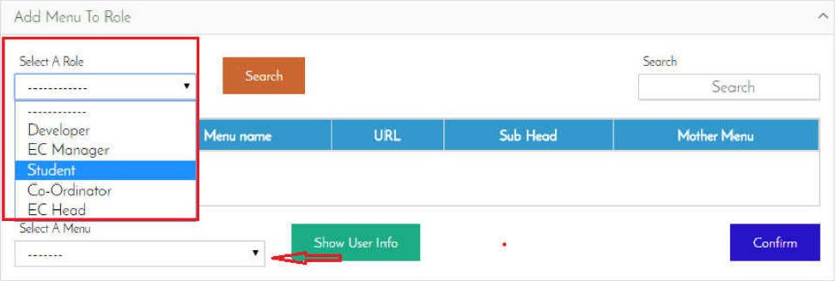

Figure 37 How to add menus to a role

* Admin can create any new role to the System:

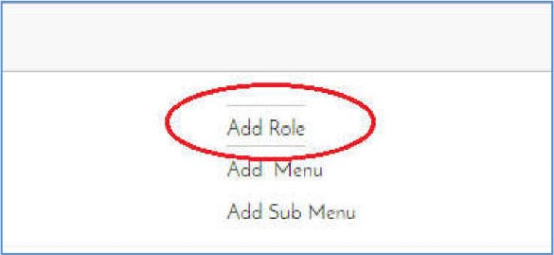

Figure

38

Option

to

add

a

role

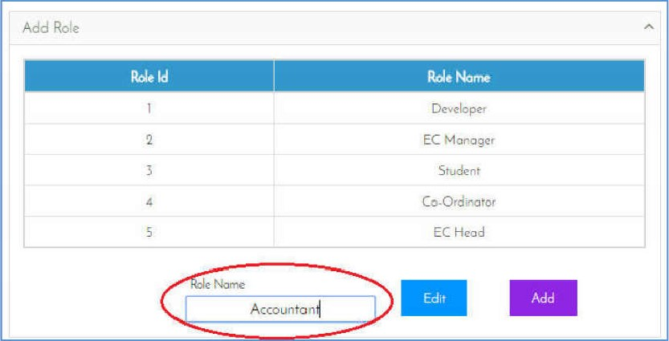

Figure 39 Role adding process

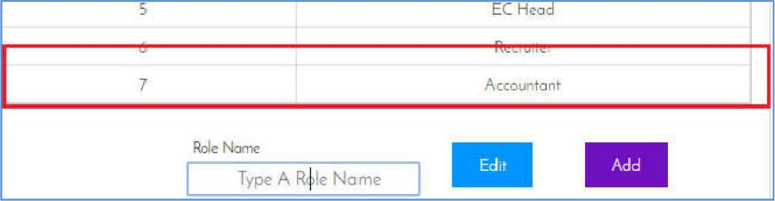

Figure 40 Role added to the list

* One more big is Admin can manage assessments by fixing date:

|  |  |
| --- | --- |
| Assessment | Manage Assessment  Assessment |

Figure 41 Assessment sub menu

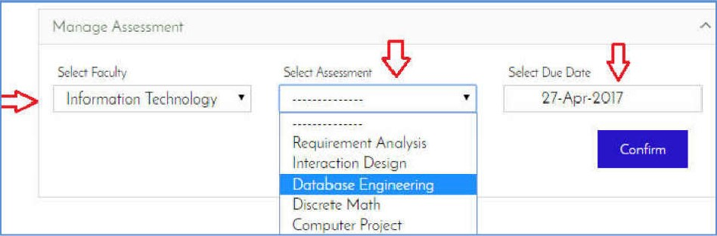

Figure 42 Manage assessment page

* Admin can add assessment by inputting names:

|  |  |
| --- | --- |
| Assessment | Mano e Assessment |

Figure 43 "Add assessment" menu option

|  |  |
| --- | --- |
| Add Assessment  Select Faculty Select Agszssmzãt Input Name   |  | | --- | | D, PMI |   Information  2  Degn |

Figure 44 An assessment input

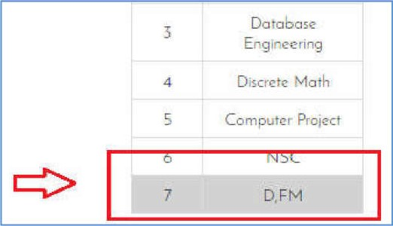

Figure 45 New assessment has been added

|  |  |  |  |
| --- | --- | --- | --- |
|  | es | o. |  |
| Test type Usability testing | | | |
| Test name Navigation testing of web pages | | | |
| Expected result Menu, links, button will be visible and accessible | | | |
| How to test Carried out by manually checks and takin screenshots | | | |
| Actual result All the navigation are visible and accessible | | | |

* This is the proof of Usability of the system:

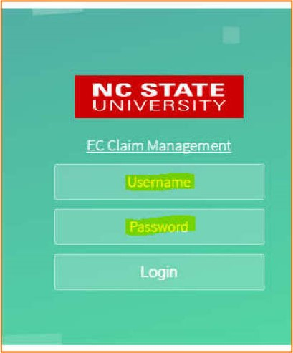

Figure

46

Usable

login

form

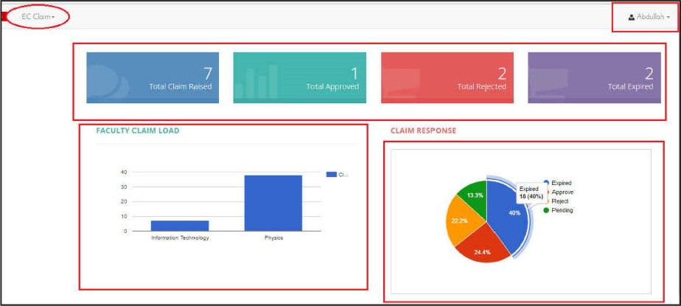

Figure 47 Navigation is are visible, Showing a accessible dashboard etc.

|  |  |  |
| --- | --- | --- |
| Claim | E-c Clam. |  |

Figure 48 accessible Menus and sub menus

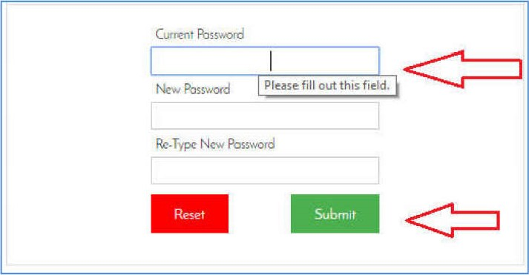

Figure 49 Clearly visible and accessible forms and buttons

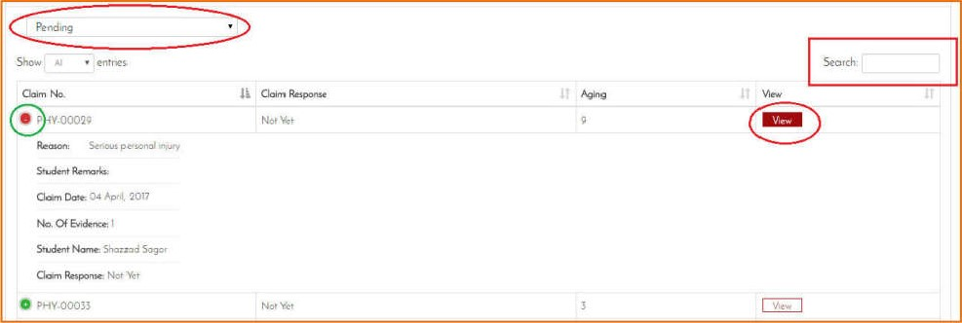

Figure 50 Another type of accessibility

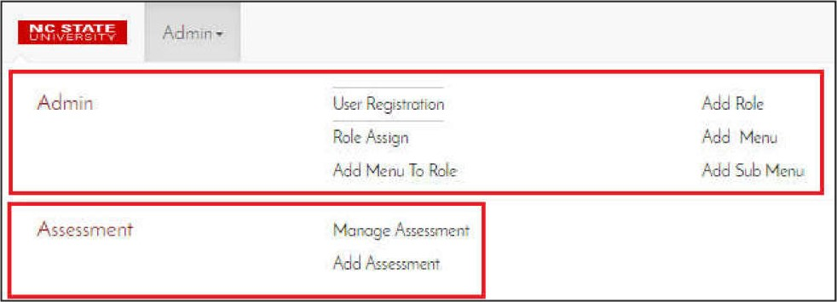

Figure 51 Accessible navigation from user perspectives

|  |
| --- |
| Test No. 13 |
| Test type Usability testing |
| Test name Content testing of WebPages |
| Expected result Pages color expected to have light color, proper image size and anchor links should be visible |
| How to test Carried out by manually checks and takin screenshots |
| Actual result Pages colors are light color, proper image size and anchor links are as exce ted |

* This section shows that the good page color(light), Propoer image size etc:

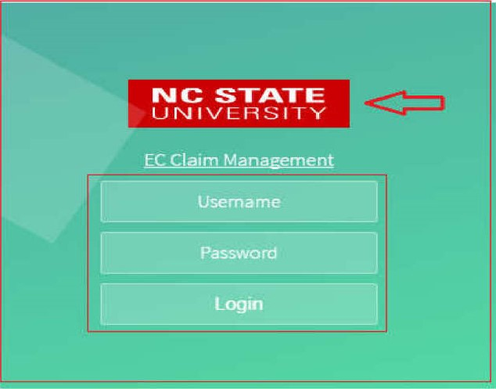

Figure 52 Login shows a good color matching with the overall interface

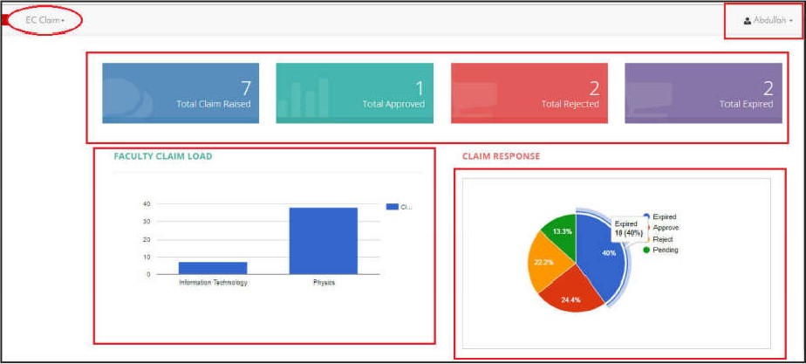

Figure 53 this section show different content color with

|  |  |  |  |
| --- | --- | --- | --- |
|  | es | o. |  |
| Test type Compatibility testing | | | |
| Test name Browser compatibility | | | |
| Expected result Testing will show compatibility in different results in different browsers | | | |
| How to test Checking the application in different browser | | | |
| Actual result App is compatible with different browser show the different | | | |

* Test with Google chrome proof of a home page:

|  |
| --- |
| FACULTY CLAIM LOAD CLAIM RESPONSE |

Figure 54 Chrome result Of Home page with dashboard

* Testing result with Mizilla firefox:

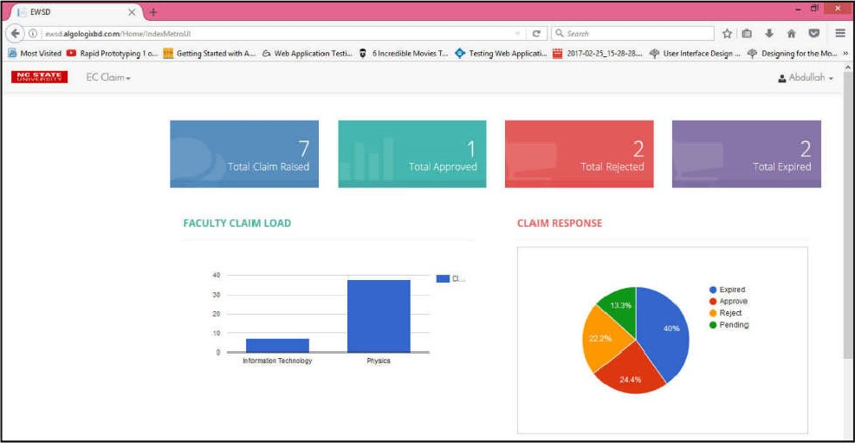

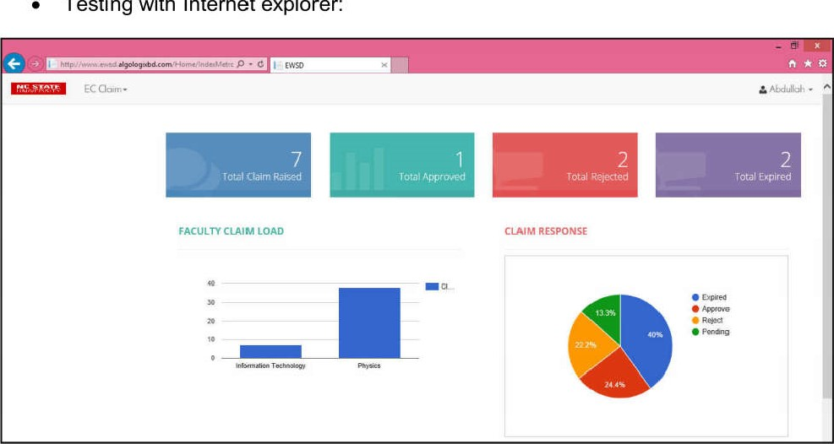

Testing

with

Internet

explorer:

Figure

55

Mozilla

Firefox

show

this

result

Figure

56

Internet

Explorer

result

of

Home

page

|  |
| --- |
|  |
| Test type Compatibility testing |
| Test name Operating system compatibility |
| Expected result Testing will show compatibility in different o eratin s stem |
| How to test Checking the app different OS |
| Actual result App is compatible with different OS browser show the different result |

* Show output from different OS and different browser:

|  |
| --- |
|  |
| Test type Compatibility testing |
| Test name Mobile compatibility |
| Expected result Application is compatible with different mobile browsers |
| How to test Checking the app in mobile browser by takin screenshot |
| Actual result Found compatibility in mobile platform |

* This show different mobile compatibility testing result or output:

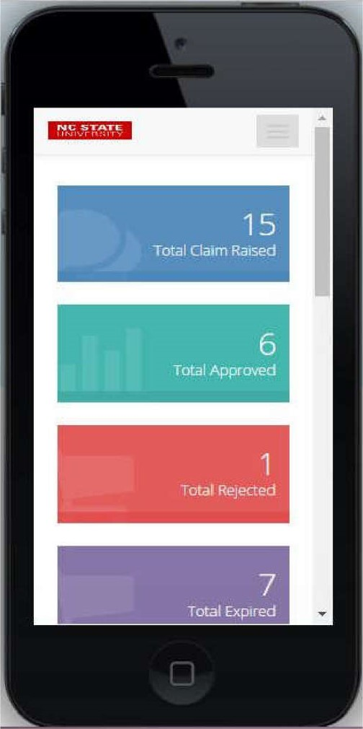

Figure 57 compatible with iPhones

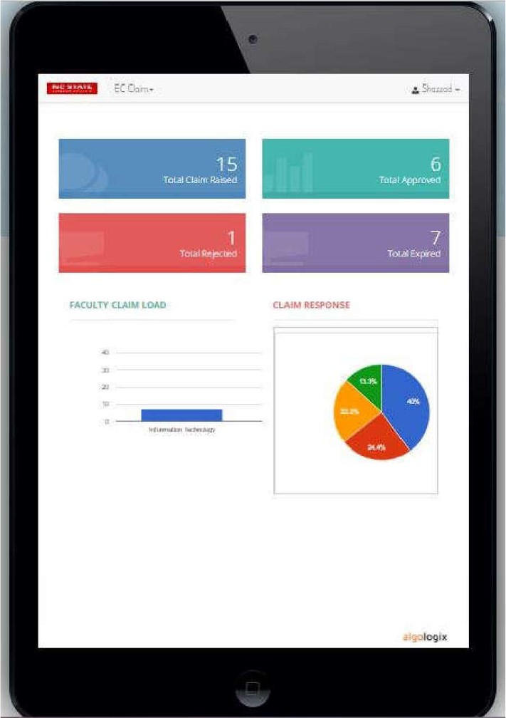

Figure

58

Compatibility

test

with

iPad

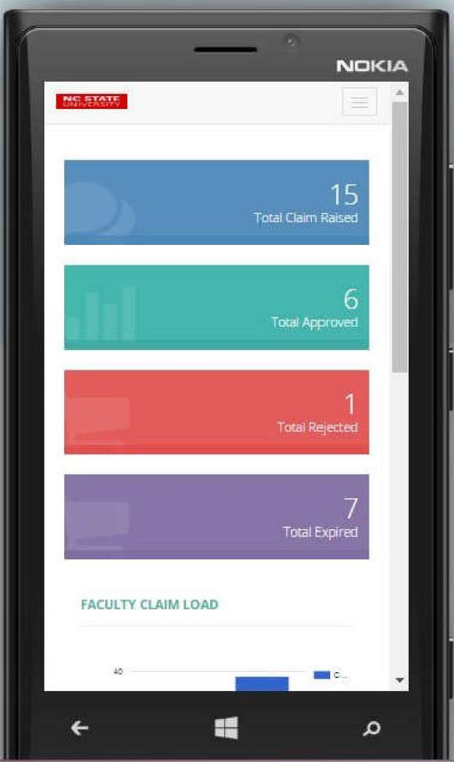

Figure 59 Compatibility testing with Lumia 920

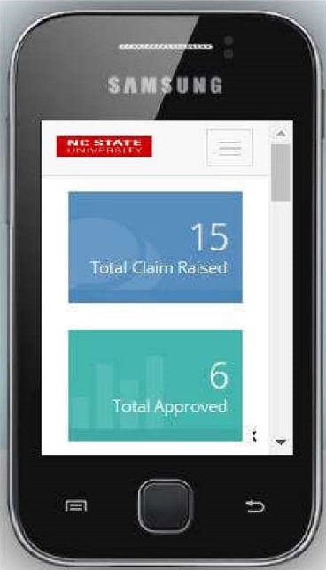

Figure 60 Compatible with a minimum smal screen Of Galaxy Y

|  |  |
| --- | --- |
| Test No. |  |
| Test type Compatibility testing | |
| Test name Printing facility | |
| Expected result Application pages are compatible during rintin | |
| How to test By providing print command and print review a e. | |
| Actual result Found printing friendly web pages | |

* Testing of how to see if a page is printed:

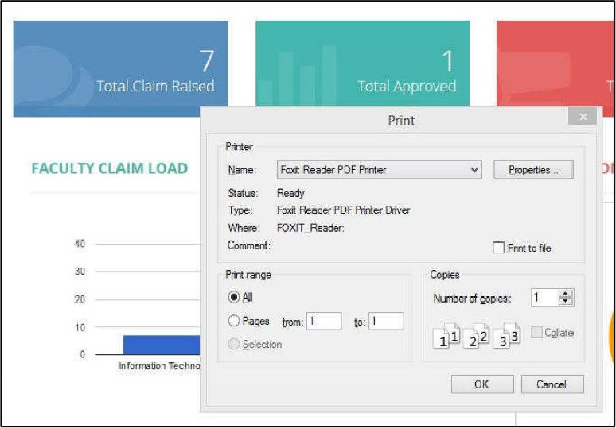

Figure 61 Providing printing command with foxit reader printer

|  |  |  |
| --- | --- | --- |
| 7  Total Claim Raised  2  Total Rejected  FACULTY CLAIM LOAD | CLAIM RESPONSE | Tcy,al  2  tOta Expired |

Figure 62 Compatibility testing with print and print preview home page

|  |  |  |  |  |  |
| --- | --- | --- | --- | --- | --- |
|  |  |  |  |  |  |
| Test type | | | | Interface testing | |
| Test name | | | | Web server interface | |
| Expected result | | | | Have to be good | |
| How to test | | | | Manually | |
| Actual result | | | | As expected | |

|  |  |  |  |  |  |
| --- | --- | --- | --- | --- | --- |
| Test No. | | | |  | |
| Test type | | | | Interface testing | |
| Test name | | | | Application server interface | |
| Expected result | | | | Good As much as possible | |
| How to test | | | | Doing manually | |
| Actual result | | | | As expected | |
| Test No. | | | | | |
| Test type Interface testing | | | | | |
| Test name Database server | | | | | |
| Expected result Behavior is good | | | | | |
| How to test Carried out manually | | | | | |
| Actual result As expected | | | | | |
|  | es | o. | |  | |
| Test type Database testing | | | | | |
| Test name Database connection | | | | | |
| Expected result Connection establishment between app and database | | | | | |
| How to test By checking default data that are connected with database | | | | | |
| Actual result Database connection has been established | | | | | |

* Testing database connection is okay in system:

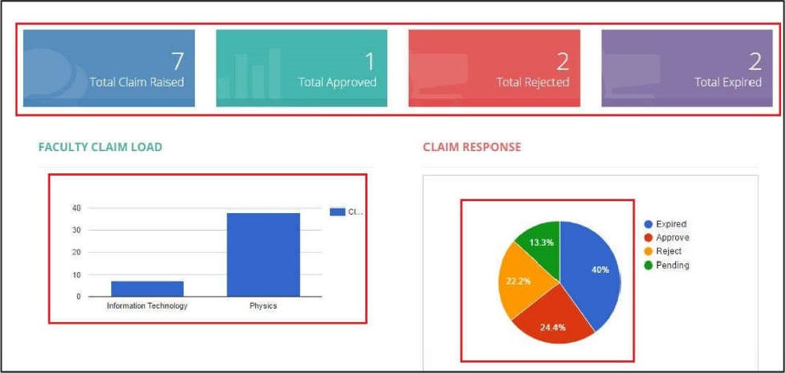

Figure 63 Figure shows database is connected with system

|  |
| --- |
| Test No.  22 |
| Test type Database testing |
| Test name Query runs without error |
| Expected result Queries will be able to run without error |
| How to test By executing a query from the application |
| Actual result Queries executed successfully |

* Queries are able to run without any error:

|  |  |  |  |  |  |  |  |  |  |
| --- | --- | --- | --- | --- | --- | --- | --- | --- | --- |
| Claim List   |  | | --- | | Pending | | Pending | | Reqnived | |  | | | Claim | Search li l | | |
| •O' PHY-00029 | | Yet  Not Yet  Not Yet  Net Yet |  |  |  |
|  |
| Claim List  -  Show  Search:  Response   |  |  |  |  |  | | --- | --- | --- | --- | --- | | O PHY-00003  O PHY-oaoc• O PHY-00005  O PHY.ooo',5 | 36 |  |  |  | |  | | Show•rng to 5 of 18 entries |  | previous | | 4 | | | | | |

Figure 64 Queries executed successfully

|  |
| --- |
| Test No.  23 |
| Test type Database testing |
| Test name Data integrity with C UD functions |
| Expected result Data consistency should be okay from affect of C U I-JD inte rit |
| How to test Operate C UD operation on portion |
| Actual result Data are consistence among the tables |
| Test No. 24 |
| Test type Database testing |
| Test name Time takes to execute query |
| Expected result Database is efficient enough to execute ueries |
| How to test Run a query and observe the duration |
| Actual result As expected |

|  |  |  |  |
| --- | --- | --- | --- |
|  | es | o. |  |
| Test type Performance testing | | | |
| Test name Web load testing | | | |
| Expected result Load testing performance | | | |
| How to test By using | | | |
| Actual result As expected | | | |

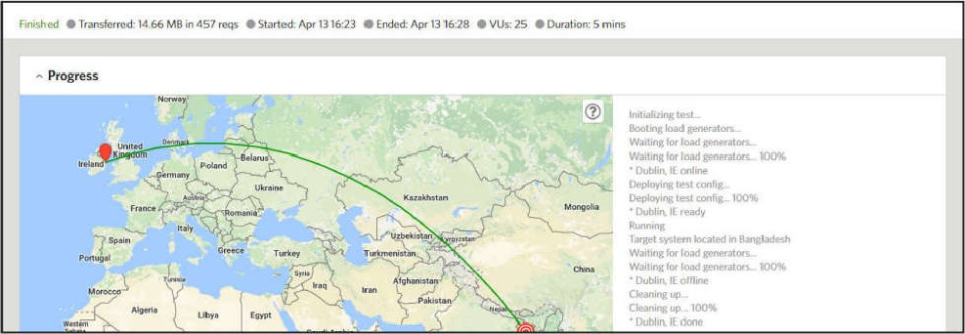

•

This

part

shows

web

load

testing

result:

|  |
| --- |
| Main chart  time |



Figure 65 the above figures show performance testing

|  |
| --- |
| Test No. 26 |
| Test type Performance testing |
| Test name Web stress testing |
| Expected result Stress testing performance |
| How to test By using |
| Actual result As expected |

* This part shows web stress testing result:

|  |  |  |  |  |
| --- | --- | --- | --- | --- |
| 20  0 Duration  Started | 14.86 Hitsgs  Avg, Throughput  20 minutes  Apr '3. PM  Apr PM | 0.03%  Test Type  Locations  Response Cades | 1.35s  Avg. Response Time  Sandöc» | 3.58s 22.66  ResponseTime Avg. Bandwidth |

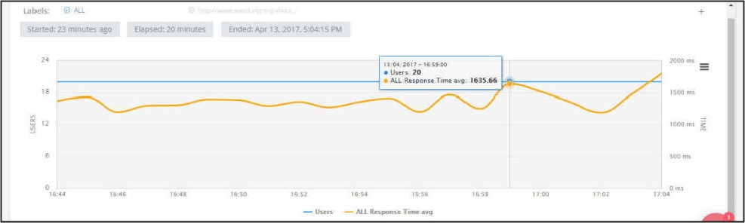

Figure

66

Show

report

the

stress

of

webApp

|  |  |  |  |
| --- | --- | --- | --- |
|  | est | o. |  |
| Test type Security testing | | | |
| Test name Force URL testing | | | |
| Expected result Doesn't allow anyone to access from direct URL exce t 10 ed in mode | | | |
| How to test Copy a URL, log out from system and aste it to address bar and hit enter | | | |
| Actual result Showing login page rather showing URL's | | | |

* Shows that system prevent to force URL•

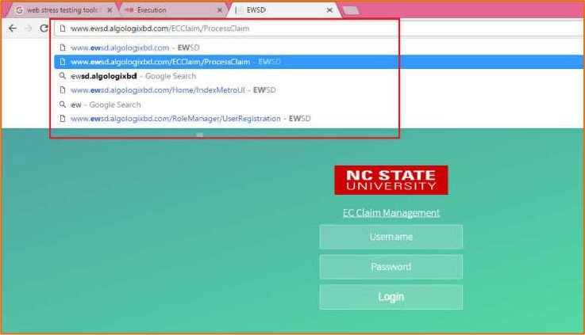

Figure

67

System

doesn't

allow

force

URL

|  |
| --- |
| Test No. |
| Test type Security testing |
| Test name Checking the passwords are encrypted |
| Expected result No one can see the real password |
| How to test Go to the database and see the password fields |
| Actual result As expected |

* The results of checking encrypted password by Hash:

|  |  |  |  |  |
| --- | --- | --- | --- | --- |
|  | | |  |  |
| Results | Messages |  |
|  | | | Password  81 DC9EDB52D04DC20036DBD8313ED055  81 DC9EDB52D04DC20036D8D8313ED055  91DC£DB52D04DC20036DBD8313ED055  81 DC9BDB52D04DC20036DBD8313ED055  81 DC9BDB52D04DC20036DBD8313ED055  81DC9BOB52D04DC20036DBD8313ED055  81DC9BDB52D04DC20036DB08313ED055 | Pseudo  NULL  819453651  1563592509  1102214029  NULL  1  NULL  1140842348 |

Figure 68 Passwords are encrypted

|  |
| --- |
|  |
| Test type Security testing |
| Test name SQL injection testing |
| Expected result System will protest sql inject problem |
| How to test Testing with a tools |
| Actual result As expected |

* Our system is fully protected from this attack, but can't check it via tools due to limited time crash possibility.

|  |
| --- |
|  |
| Test type Security testing |
| Test name Brute force attack |
| Expected result System able to protest brute force attack |
| How to test Testing with a tool |
| Actual result As expected |

* Shows the result of this:

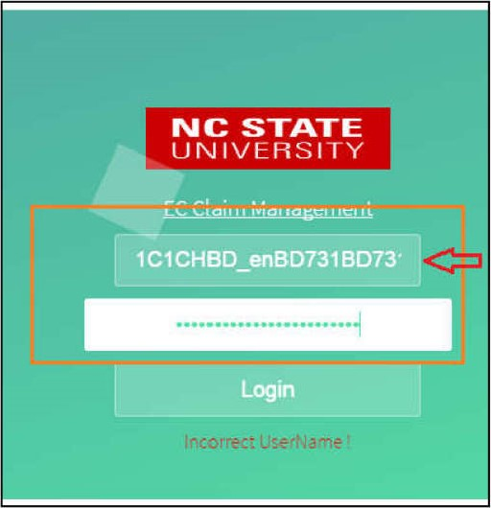

Figure

69

an

attempt

to

attack

hacking

password

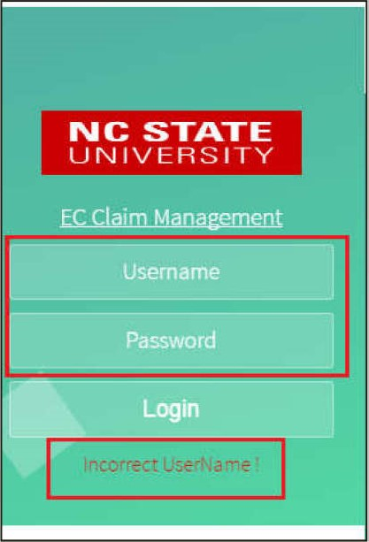

Figure

70

Prevents

illegal

access.

|  |
| --- |
| Test No. |
| Test type Security testing |
| Test name Authentication testing |
| Expected result Unauthorized user cant access to the s stem |
| How to test Try to access to the system by putting unauthorized ID and asswords |
| Actual result Shows wrong username and password |

* Authenticated user login role based by input wrong id password:

|  |  |
| --- | --- |
|  |  |
| Login |
|  |

Figure 71 Unauthorized username and password entered

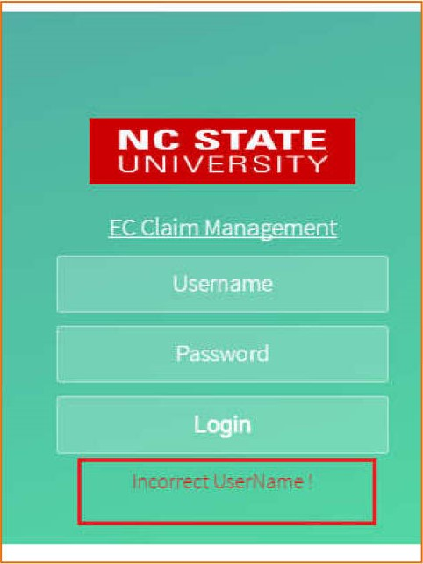

Figure

72

Shows

"Incorrect

username"

|  |  |
| --- | --- |
|  | est No. 28 |
| Test type Crowd testing | |
| Test name Carry out by specific group of non technical erson end user | |
| Expected result Positive attitude and feed to the system | |
| How to test Let that three (3) person to use the s stem for a while | |
| Actual result As expected | |

References:

Kota, K. (2016) AdminiTrack, Inc., 10 October, [Online], Available:

https://www.adminitrack.com/articles/testingyourwebapps.aspx [2017 March 25].

Pressman, R. (2010) Software Engineering, 7th edition, New York: McGraw-Hill Companies, Inc.

SoftwareTestingClass.com (2012) softwaretestingclass.com, 12 November, [Online], Available: http://www.softwaretestingclass.com/web-application-testing/ [27 March 2017].

softwaretestingfundamentals.com http://softwaretestingfundamentals.com, [Online], Available: http://softwaretestingfundamentals.com/test-plan/ [10 March 2017]